**** Coordinate Geometry of Two Dimensions

• Circle

• Conic Sections

**** Three-dimensional Coordinate Geometry

• Vectors

• Equations of Lines and Planes

**** Function of several Variables

• Partial Derivatives

• Maximum and Minimum Values

**####### Reference book: Calculus-James Stewart-Eighth Edition**

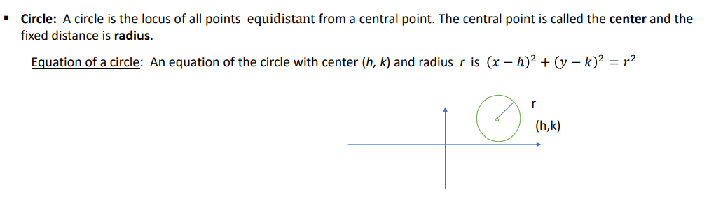

**Example:**



